**Gold rates of different countries and how does country's economy change affect them.**

TABLE OF CONTENTS

* INTRODUCTION

* INFORMATION ABOUT DATA

* VISUALIZING THE GOLD RATES IN DIFFERENT CURRENCIES

* VISUALIZING EFFECT OF 2008'S FINANCIAL CRISIS ON GOLD RATES

* COVID 19 AFFECTING GOLD RATES?

* VISUALIZING EFFECT OF COVID 19 ON GOLD RATES

* USUALLY WHICH MONTHS HAD LOWEST GOLD RATE RECORDED?

* CONCLUSION

INTRODUCTION

This notebook contains Exploratory Data Analysis of Gold rates of five countries: United States, India, Europe, Great Britain and China. Answers to such questions like How 2008 World financial crisis affected the gold rate? What effect did COVID 19 had on gold rates of above mentioned countries? Can be found in this notebook

INFORMATION ABOUT DATA

USD - Price of gold in US Dollars

EUR - Price of gold in Euros

GBP - Price of gold in pounds

INR - Price of gold in Rupees

AED - Price of gold in Dirhams

CNY - Price of gold in Chinese renmimbi

The gold rates are in per troy ounce in their national currency ( 1 t oz = 31.1g)

1. VISUALIZING THE GOLD RATES IN DIFFERENT CURRENCIES

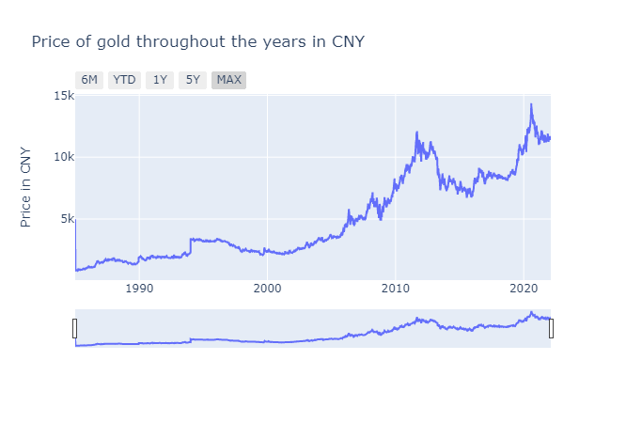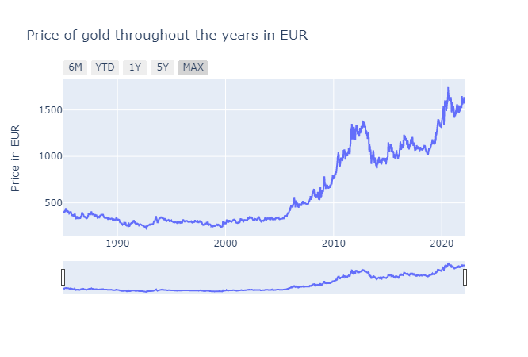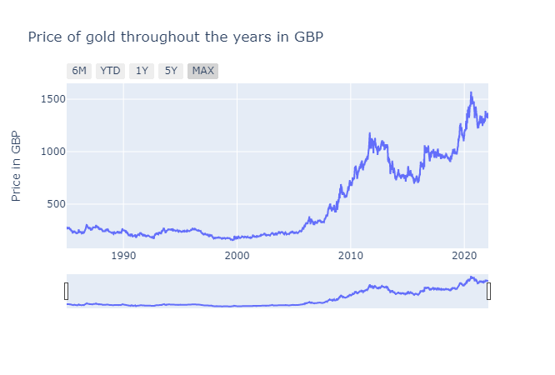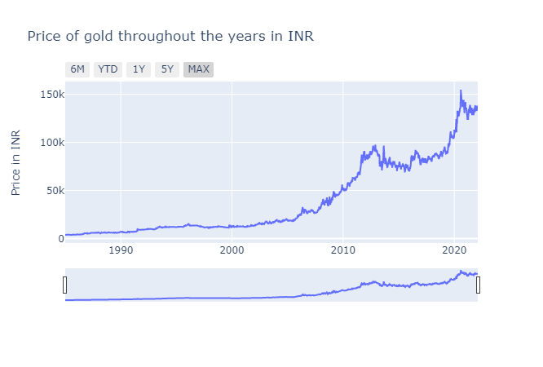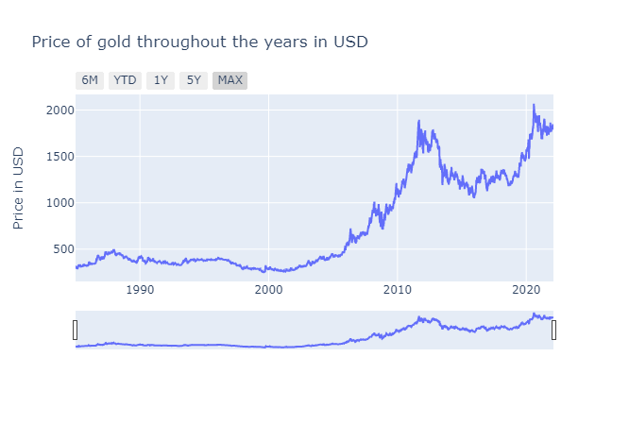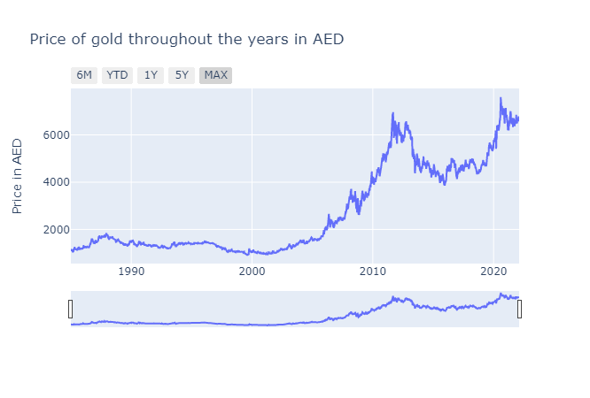

* Summary :

We can observe from the above graphs that all these currencies share the same trend of gold prices throughout the year. They all increase in a similar manner, just a slight difference in INR around 2012 but apart from that it's same.

2. VISUALIZING EFFECT OF 2008'S GLOBAL ECONOMIC CRISIS ON GOLD RATES

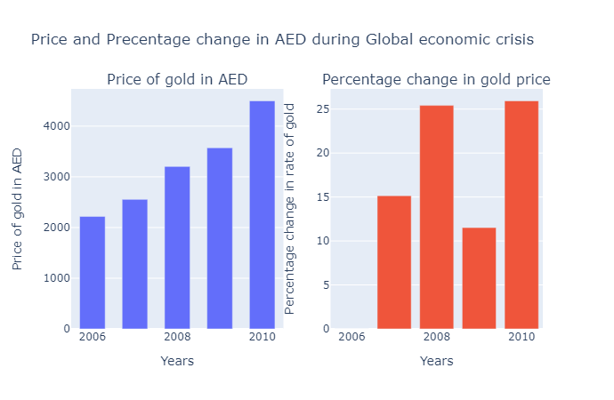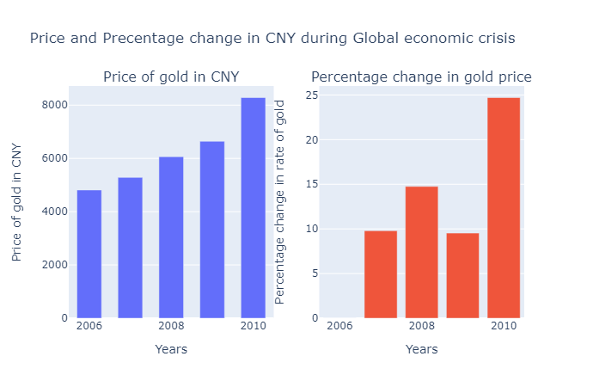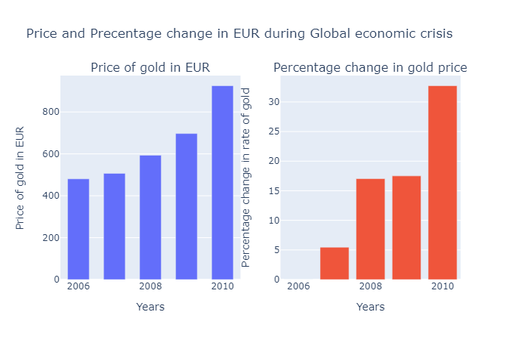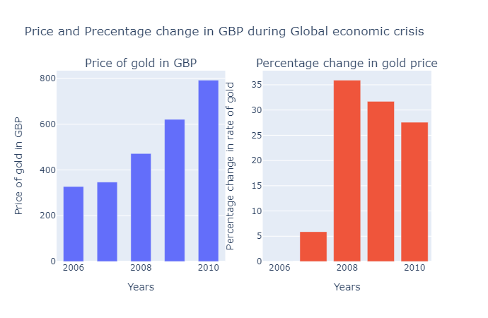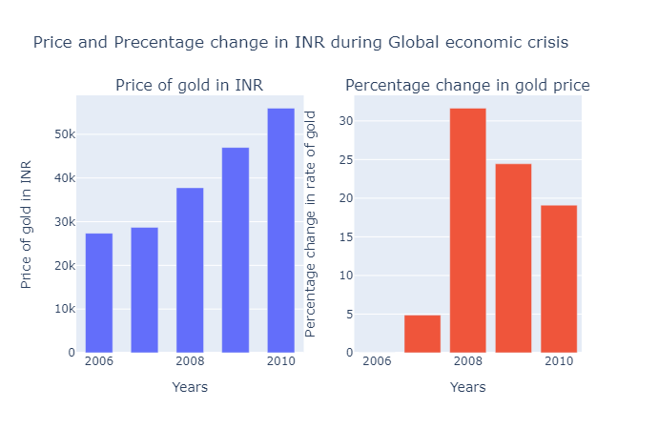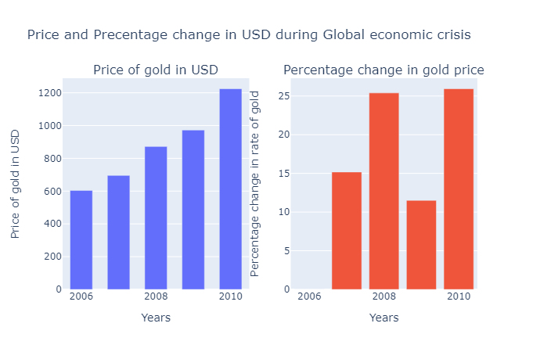

* Summary:

Why gold is identified as safe haven by investors over the years against inflation and economic crisis? We can see the result above. Let me explain, as the economic activities start to roll down, there are fewer investment opportunities that are better than gold. Against a falling currency and falling equity, investors keep their eyes on gold. The economic crisis is always remembered as a lucrative instrument for the gold market. After 2008, as the globe encountered an economic slowdown, gold rose considerably.

As we can see from the above plots

* US had 25.4% increase in gold price in 2008
* Europe had 17.4% increase
* Great Britain and India had one of the highest jumps in the gold rates, a whopping increase of 36% and 31.6% respectively
* UAE had 25.4% increase
* China had 14.75% increase

During the US economic crisis, investors realised again that their equity and currency can fall suddenly, overnight and could leave them even bankrupt. But investing in gold portfolios like gold ETF, gold bonds will always save them from these kinds of crises

3. EFFECT OF COVID 19 ON GOLD RATES.

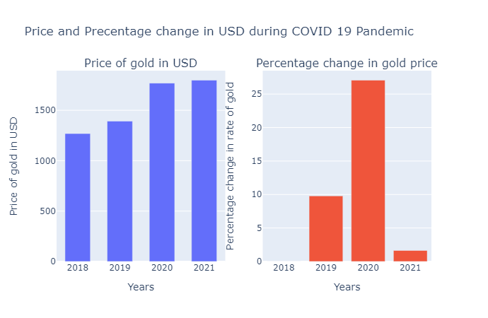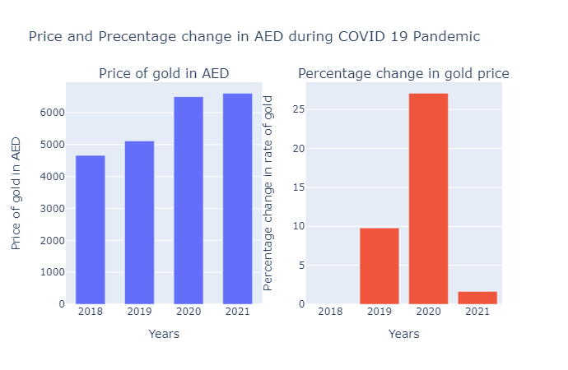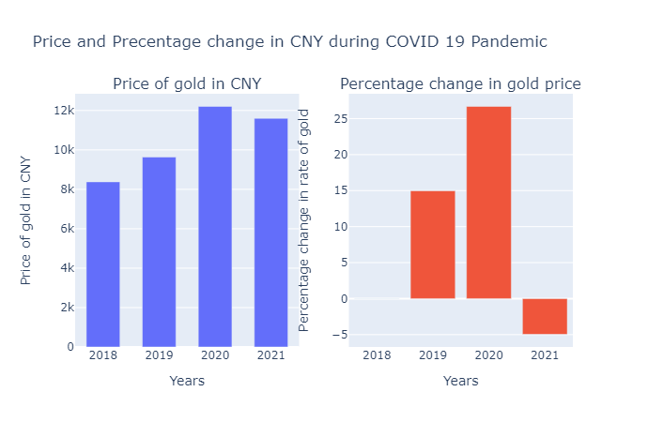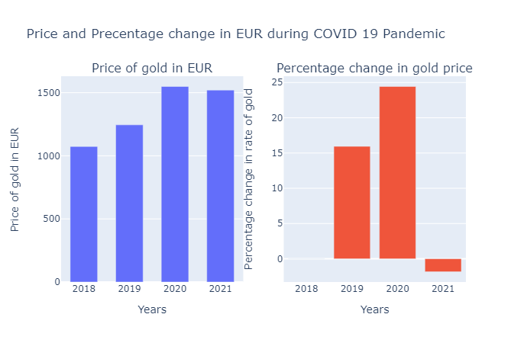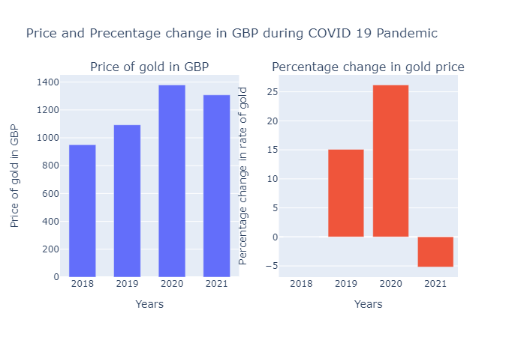

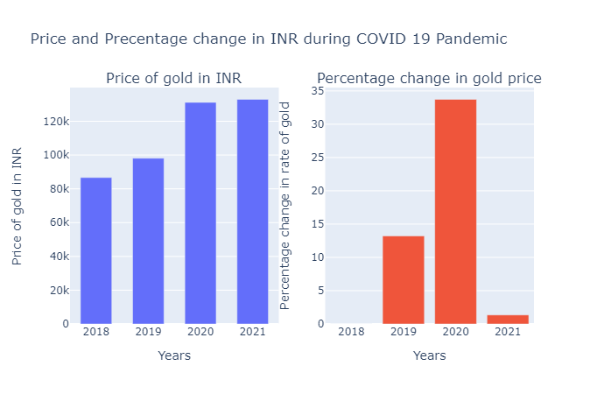

* SUMMARY:

COVID 19 pandemic started around Jan 2020 in the countries mentioned in the dataset. COVID 19 also had a catastrophic impact on economy as well as health. From the observed result during 2008's crisis viz. we can say that whenever a crisis hits and damages the economy of a country or when there is an inflation the prices of gold tend to rise. There was a significant increase in the gold rates in 2020 from the year before that. India had the highest percentage increase of 33.73%

4. MONTHS WHICH THE GOLD RATES ARE AT THE LOWEST IN THE YEAR (EXAMINING THIS TREND FOR 2014-2021)

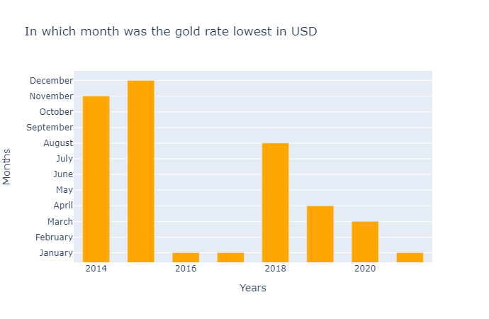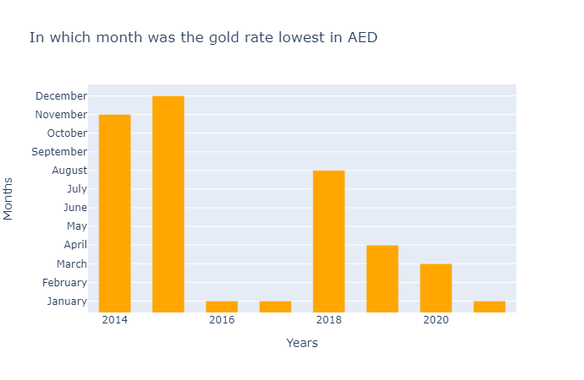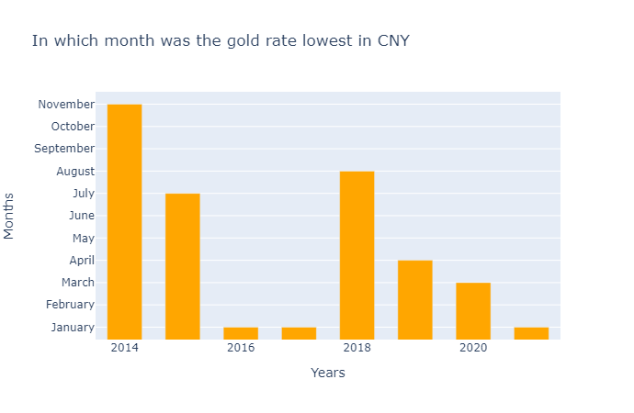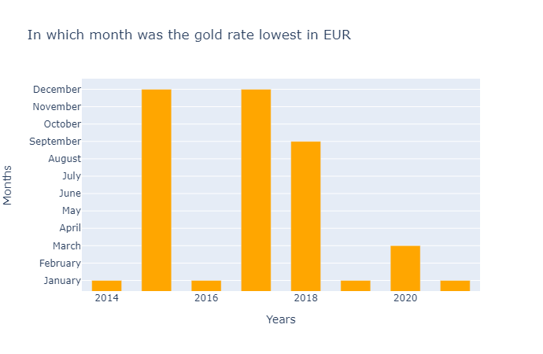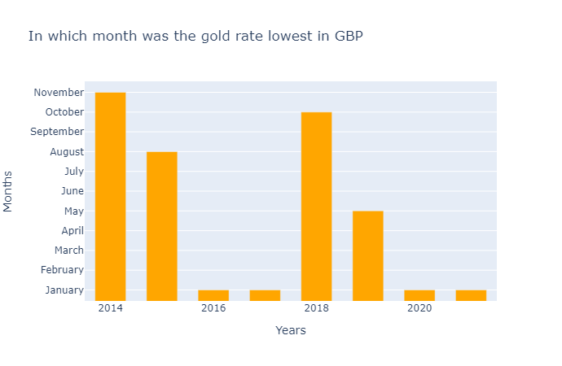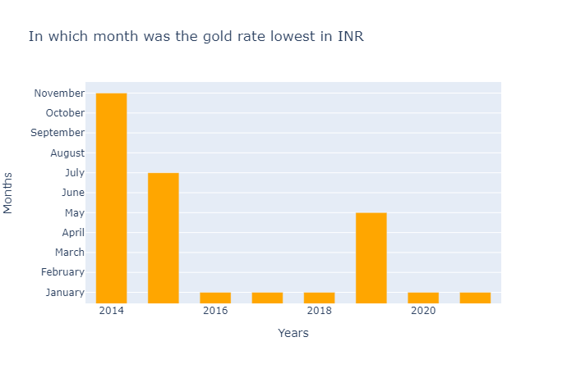

* Summary:

As we can see that the gold rate is usually lower in start of the year but that's not the case always. India had the lowest gold rate in January in years 2016,2017,2018,2020 and 2021. So if you are looking to buy gold, buy it in start of the year

* CONCLUSION

Economic crisis is an important factor which contributes towards the rate of gold in different countries. From our above analysis we can conclude that whenever there is an economic crisis in any country for example during 2008 or COVID 19 the price of gold tends to increase. During such crisis investors always rely on gold when the economy is falling apart. We can also say that the relationship between gold prices and stock markets is inverse. More often than not, the gold prices would drop when the stock markets perform well and vice versa. When the stock markets collapse, the demand for gold increases as more and more investors would be looking at safer options. Gold has been considered the safest investment avenue since the millenniums. Even a small disturbance in the global market sets the prices of the yellow metal rolling. From natural disasters to war, and even economic crisis, the gold rate is highly sensitive to such stimuli. Lastly, when the demand for this safe haven asset (gold) goes up, its prices also shoot up.